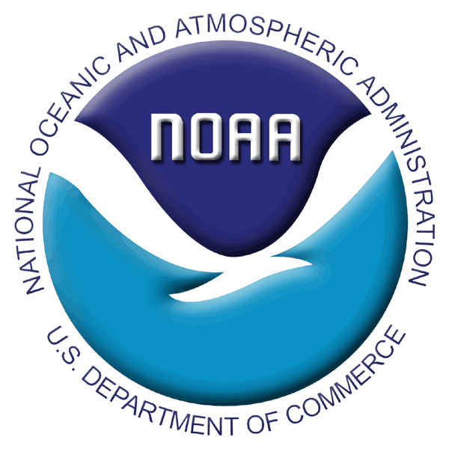
Scientific Projects and Collections Application Form
2011 RACE Bottom Trawl Surveys – EBS Shelf

Priority: High priority – 1 (Pathobiology Milestone #2)

PROJECT OVERVIEW
- Project Title: Bitter Crab Syndrome
Principle Investigator (PI)/Point of Contact: Frank Morado
Affiliation: AFSC/RACE
Address: 7600 Sand Point Way NE, Bldg 4, Seattle, WA 98115
Email: Frank.Morado@noaa.gov Phone: 206.526.6572

2. General Description: Bitter Crab Syndrome (BCS) is a fatal disease of commercially important Chionoecetes species of the North Pacific and is emerging worldwide in other decapod hosts. Odd years are which king crabs and other crustaceans are targeted for sampling. We would like to investigate the possible presence of BCS in non-Chionoecetes decapods crustacean, using an opportunistic sampling plan.
The proposed project has implications for the following AFSC research priorities:
a. Investigate the role of pathogens and parasites in vitality of marine fish and shellfish populations & as biomarkers of anthropogenic and environmental change on stock health b. Develop DNA-based genetic baseline data for selected species of groundfish and forage fish to establish stock structure and stock boundaries
c. Assist in implementing and improving data collection programs that support economic and social research

COLLECTION PROTOCOL

3. Detailed collection procedures:
What: Hemolymph from the following species when available:
Paralithodes spp., Hyas spp., Pagurus spp., E. isenbeckii, Elassochirus spp., shrimp
When: After routine haul duties, all three legs of EBS survey, Aldebaran only
Who: Pathobiology staff will take collections.
Collection methodology: Record species, sex, shell condition, morphometry, visual BCS status, plate #, vessel, cruise and haul. Using a syringe draw 0.2mL hemolymph from the arthrodial membrane. Preserve hemolymph sample in 100% ethanol stored in pre-filled 96-well plates.
Quantity: up to 2000 hemolymph samples (~650 per survey leg)

4. List of supplies: We will provide 2200 1mL syringes, calipers, 21 96-well plates, sharps containers, biohazard bags, datasheets, shipping materials

5. Data storage: We do not require data storage in the Groundfish database, but would like to relate our data to haul level data.

6. Hazardous materials: 100% Ethanol (filled into 96-well plates prior to survey).

7. Personnel available to help with project and overall survey mission:
Frank Morado, (206) 526-6572, Frank.Morado@NOAA.gov
Christie Shavey, (206) 526-6715, Christie.Shavey@NOAA.gov
Pam Jensen, (206) 526-4122, Pam.Jensen@NOAA.gov
Vanessa Lowe, (206) 526-4107, Vanessa.Lowe@NOAA.gov
8. Estimated time and resource expense: 20-30 min per opportunistic station, after survey tasks are complete. Staffed Pathobiologist will collect samples when available.

SHIPPING
9. 24/7 contacts: Christie Shavey (206) 526.6715, Vanessa Lowe (206) 526.4107, Frank Morado (206) 526.6572

10. Detailed shipping instructions:
Shipping: Will use AFSC shipping van to and from Dutch Harbor.
Collection plates: Outer container is a solid 5-gallon plastic twist top labeled bucket. Inner containers are 96-well plates (1.2 ml wells) containing ethanol and sample individually sealed in plastic bags with absorbent spill pad. Hazardous materials will be contained in a properly labeled bulk container (42x29x28”) during shipment.
Used syringes will be transported in autoclave bags to be disposed of at AFSC.
Used needles will be contained in sharps containers and disposed of at AFSC.

PERMITS
11. Permits issued: ADF&G Fish Resource Permit

